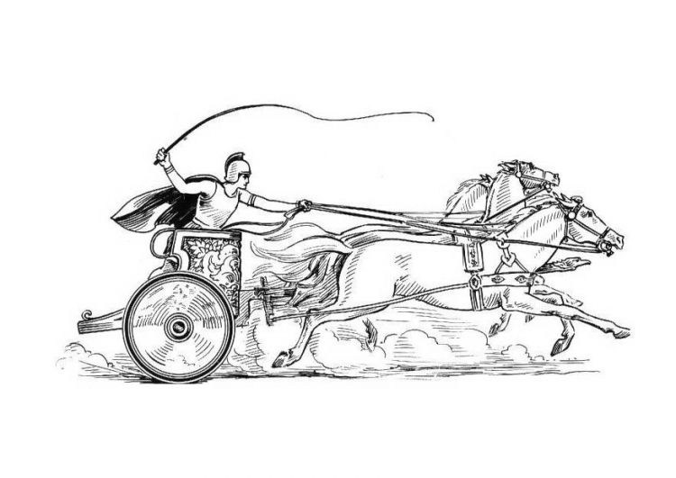

**Minutes of the Annual Parish Meeting**

**Of the Parish of Mancetter**

Minutes of the Mancetter Annual Meeting of Parishioners held on

Tuesday 23rd May 2023 commencing at 7pm in the School Room, St. Peter’s Church Mancetter.

Present:

**Chairman** Trevor Hopkins.

**Parish Councillors** Harry Blackburn, Sue Healy, Peter Mann, John Tither and Nicola Wallis.

**Parish Clerk** Elane Higgins.

**Assistant Clerk Finance** Karen Meads.

**Borough Councillors** Keith Barnett, Denise Clews.

**County Councillor** Margaret Bell.

**County Highways** Jeff Morris, Graham Stanley.

**Police** Inspector Alison Wiggin, PCSO Emily Jenkins.

**Parishioners** 10 people attended the Annual Parish Meeting in addition to those listed above.

**1. Welcome and Apologies**

The Chairman welcomed all present to the Annual Parish Meeting for 2023.

Apologies had been received by Parish Councillor Glynis Forknall, Ridge Lane WI and Neighbourhood Watch representative Jill Mawson, Melanie Smith, secretary to the Roman Mancetter Exhibition

and Mancetter resident J Arrowsmith.

**2a. Minutes of the last meeting**

The minutes of the previous Annual Parish Meeting on 26th April 2022 had been reviewed, and therefore were formally signed at this meeting by the Chairman for the records.

The Informal meeting in September 2022 took the form of two charity auctions, one in Mancetter and one in Ridge Lane.

The recycled shields made by councillors, and decorated by the community for the Platinum Jubilee, were auctioned and there was another opportunity to complete the 70-year trail of historical facts.

Mock up designs of village gateway signs were on display and feedback obtained from those present at each meeting.

£300.00 was raised and added to the proceeds of the Macmillan Coffee Morning run by Mancetter Memorial Hall.

**2b. Matters arising from the previous meeting**.

All matters from the previous meeting had been dealt with.

**All reports marked * are available to read in full on request**

**in the Parish Council office within Mancetter Memorial Hall.**

**3. Borough and County Councillor Reports.**

As this was Keith Barnett’s first meeting as an elected Borough Councillor, Denise Clews gave the feedback from the Borough Council as the re-elected representative. A Funding contribution has been allocated towards CCTV cameras at St Peter’s Church following incidents of anti-social behaviour. The remaining amount from the Borough Councillor funds were used to part fund the new zip wire planned for the refurbishment of Mancetter Recreation Ground in the Summer.

County Councillor Margaret Bell has been actively involved in raising highway concerns, and recognises the frustration of local residents with speed and traffic volumes. The implications of making Woodford Lane left turn only are already being seen in Mancetter, and the amount of HGV’s passing by the grade II listed cottages opposite the church is unprecedented.

Issues with planning enforcement in relation to travellers’ sites within the parish have also taken up a lot of her time. Questions concerning Public Rights of Way and the electricity supply to the site at Kirby Glebe were asked.

**4**. **Introduction to Police Inspector / Matters for the Police.**

Alison Wiggin is the Neighbourhood Inspector and Head of the Rural Crime Team.

There is now a Chief Inspector specifically for North Warwickshire called Steve Davis.

The Community Safety teams have been severely understaffed, but recruitment and training are finally resulting in additional officers.

Mancetter and Ridge lane are one of four areas earmarked for levelling up funding to tackle social problems relating to Finance, Mental Health and above average cases of Domestic Violence.

A high number of silent 999 calls are being received. Vehicle theft is relatively low in relation to anti-social behaviour and fly tipping, with only 12 vehicles reported as stolen over the last 12 months.

PCSO Emily Jenkins provided an update on recent crime statistics, and explained the purpose of the Cuppa with a Copper initiative.

**5. Introduction to County Highways / Traffic Road Safety Issues**

Jeff Morris and Graham Stanley attended the meeting on behalf of the Highways Department at Warwickshire County Council.

The weather conditions over the winter have seen a nationwide increase in pot holes. Temporary fixes are gradually being replaced by permanent repairs, and members of the public are encouraged to report any ongoing concerns to County Highways. Reece Berry is the Locality Officer for this area.

The possibility of a raised table crossing near the Church to help with crossing the road was mentioned as well as the commissioning of an up-to-date traffic survey to obtain hard data evidence of traffic speeds and volumes.

The speed signs on the approach to the Mancetter Island from the Nuneaton direction of the A5 are confusing, and encourage drivers to enter Harpers Lane at 50mph despite the signage stating that they are entering a 30mph zone.

Dana Loxley from the Highways Safety Engineering team has been looking at improvements to the Woodford Lane junction and a request for some additional funding for Mancetter to help with the installation cost of moveable speed signs was suggested. Moveable signage could then be deployed to different hot spots within both villages.

The Parish Council would also like to get the go ahead for new village gateway signs.

**6. Chairman’s Report \***

The Chairman, Mr T Hopkins gave his annual report for 2022/2023 as Chair of Mancetter Parish Council and a copy was distributed to all those present. The report will also be published on the Parish Council Website.

**7. Financial Officer’s Report \***

Mrs K Meads, as the former Responsible Financial Officer of the Parish Council, gave her report and also distributed a copy to all members of the public in attendance.

**8. Parish Councillor Vacancies**

The Parish Council consists of 8 councillors. **Following the recent local elections, a vacancy exists for one more councillor to join the team, and anyone interested should make contact with the Clerk.**

**It was decided at this point to break for refreshments and give residents opportunity to chat directly with councillors, police and highways representatives.**

**9. Feedback from Organisations and Community Groups Invited.**

**St Peters Church**

The Rev Linda Mudd spoke about working in partnership with the Christian organisation Restore Collective to provide support to families through involvement at Outwoods school.

A very positive St Peter’s Church Childrens team run fun activities for local children celebrating events throughout the year. A community choir meets at Church on a Thursday afternoon and all are welcome to join. Connections lunches to promote interest in history and heritage, involving a guest speaker and two course lunch from the Saddlery is a popular Wednesday afternoon activity once a month.

**Roman Mancetter Exhibition**

Eddie Smallwood, proprietor of Legions to Legends and a member of the Civic Society and Roman Mancetter Committee, spoke about how the exhibition is growing in popularity with over 900 visitors coming through the doors.

Organised tours by Legions to Legends are promoting the rich Roman History of the area which is a serious contender for the site of the final battle between the Romans and the forces of Boudicca warrior queen of the Iceni tribe.

A scale model of the proposed battle site has been funded by Mr Eddie Smallwood and is on display within the exhibition.

Schools are booking class trips to see the exhibition and take part in interactive activities. 59 pupils are arriving on Friday this week for a tour.

**It is essential that County Highways recognise the need for a safe place to cross the road as visitor numbers and vehicle numbers increase.**

**Mancetter Community Group**

Sandra Holt is the Chair of the Mancetter Community Group which has been running for 15 years now, providing weekly indoor bowls (depending upon numbers) on Wednesday afternoons, and bingo sessions on Thursday evenings both at Mancetter Memorial Hall.

They will be organising their annual trip to the seaside at Skegness, which is open to all Mancetter residents subject to spaces, and takes place at the beginning of August each year.

**Gramer Cottages, Mancetter Scouts and Little Stars Nursery.**

There was no representation from these groups and organisations at the meeting.

**Mancetter Memorial Hall Committee**

Caroline Foster fed back that Mancetter Memorial Hall, continues to support a wide range of events and activities for the local community.

Regular groups and activities include Mind mental health drop ins and individual appointments, brownies and guides, karate, Tai chi, bowls, women’s institute, tea and chat community cafe, bingo, mature movers and a thriving youth group.

Work has taken place to install LED lighting and to carry out essential repairs to the guttering and car park.

**Mancetter WI**

Mancetter WI continues to meet on the 2nd Wednesday of the month at Mancetter Memorial Hall and also have a monthly craft group at St Peter’s. In November they would like to make a display of handmade recycled poppies for the village green in preparation for remembrance, which everyone agreed is a lovely idea.

**Atherstone District Rainbows Brownies and Guides**

Karen Meads highlighted some of the many interesting activities that each group gets up to on a Monday evening at Mancetter Memorial Hall between 5pm and 9pm. There are waiting lists to join the groups and volunteers to become leaders are always welcomed. Particular fun was had at Christmas following clues on a Snow man and Snow dog trail to find Father Christmas.

**Neighbourhood Watch**

Mancetter has its own Neighbourhood Watch group and Ridge Lane and Birchley Heath have joined together to monitor issues in both villages. Both have a face book presence and share information online.

**Ridge Lane Chapel and Community Room**

The Methodist Chapel and Community Hall continues to provide a room for meetings for the Ridge Lane WI, youth club, tea and toast and neighbourhood watch. The building is well used and appreciated by the local community and is the only place in the village large enough to accommodate families or groups. The tea and toast community café which meets on a Monday morning is well attended and helps to alleviate loneliness and promote social interaction.

**Ridge Lane Youth Group**

Ridge Lane Youth Group have 6 members and continue to meet on Tuesday’s from 5pm -7.30pm for children between the ages of 6 and 13.

**Ridge Lane Allotments**

All allotments are currently let and thanks were given to the Parish Handyman for maintaining the communal areas.

A sharing scheme has been implemented to give those interested in becoming an allotment holder chance to cultivate some land under the guidance of an experienced gardener.

**Ridge Lane WI**

Known as the “Bluebelles” in recognition of the beautiful annual display of bluebells within the parish, the group has 15 members who have been enjoying talks on various subjects. The Christmas meeting made door wreaths which made Ridge Lane look very festive.

Jill Mawson has become the new secretary and has organised a monthly litter picking group to help keep the village looking tidy.

They are planning an Autumn fundraiser involving fun and cakes in the true WI spirit.

**10. Any Other Parish Business**

There were no other matters that people wished to discuss, therefore Trevor thanked everyone for their attendance.

He also thanked Katie Meads and Girlguiding for providing the refreshments.

The meeting closed at 9.25pm.

**11. Date of next Parishioner meeting** will be Wednesday 20th September 2023 7pm at Mancetter Memorial Hall.



Manduessedum - Mancetter Village

(Place of War Chariots)

**M**ancetter **P**arish **C**ouncil

Serving the People of Mancetter and Ridge Lane